2.3 The head section: title, meta charset, meta viewport
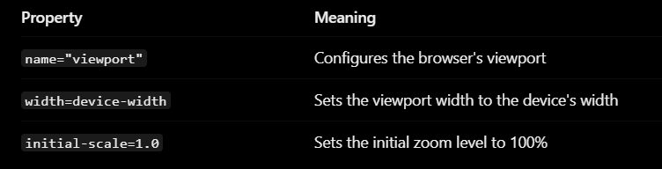

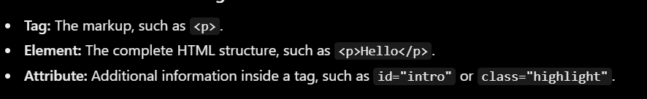
2.4 Elements, tags and attributes (id, class)

